Data Visualization
- Data visualisation is the process of creating graphical representations of data to help people understand and explore the information. The goal of data visualisation is to make complex data sets more accessible, intuitive, and easier to interpret. By using visual elements such as charts, graphs, and maps, data visualisations can help people quickly identify patterns, trends, and outliers in the data.

visualizations
Link: https://drive.google.com/file/d/1Gew9TcVNBWdIT8n5Zhk1-mV8xpRa5E5_/view?usp=drive_link
Activity 1.1: Top Brands:

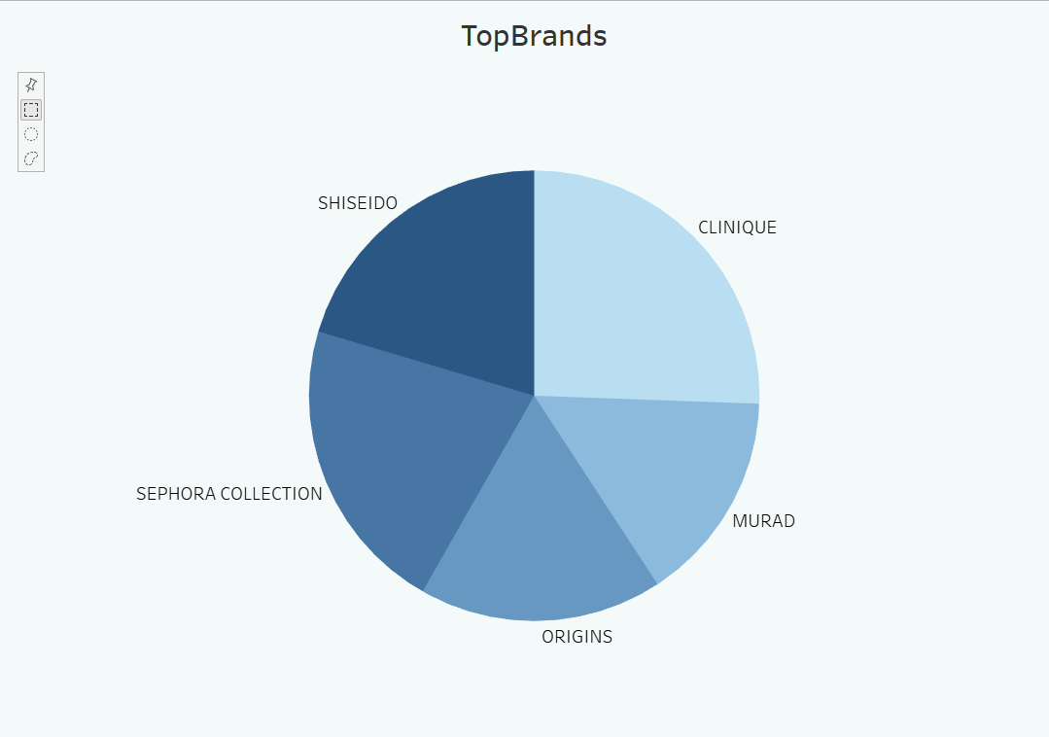

Activity 1.2: Label Count
Explanation Link: CosmeticsLabels.mp4
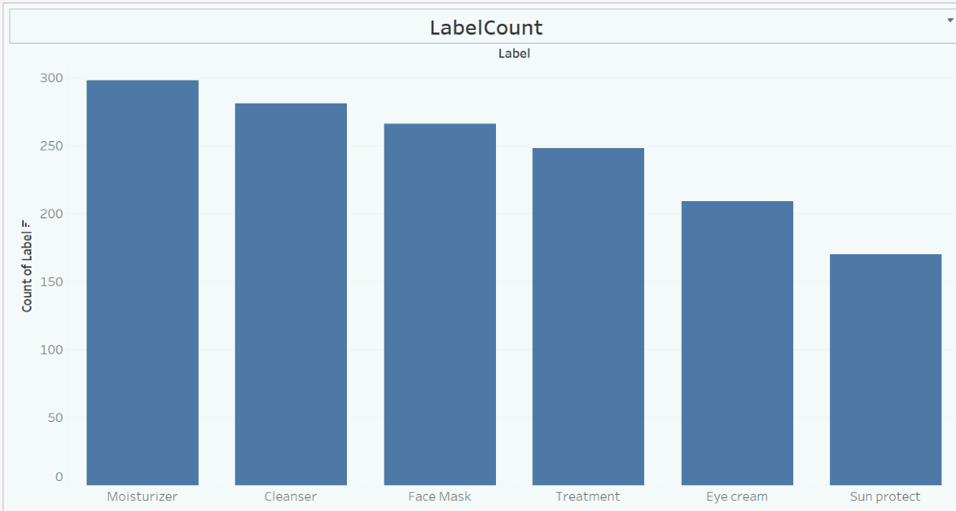

Activity 1.3: Price vs Brand
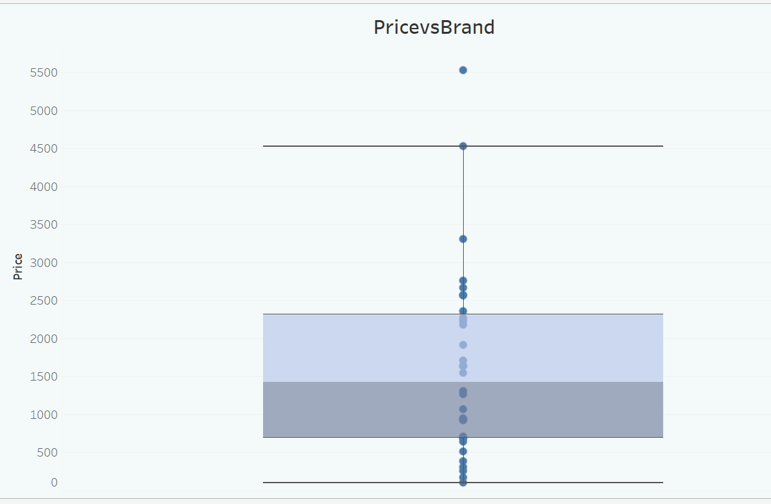
Activity 1.4 : Sensitive Skin Suitability
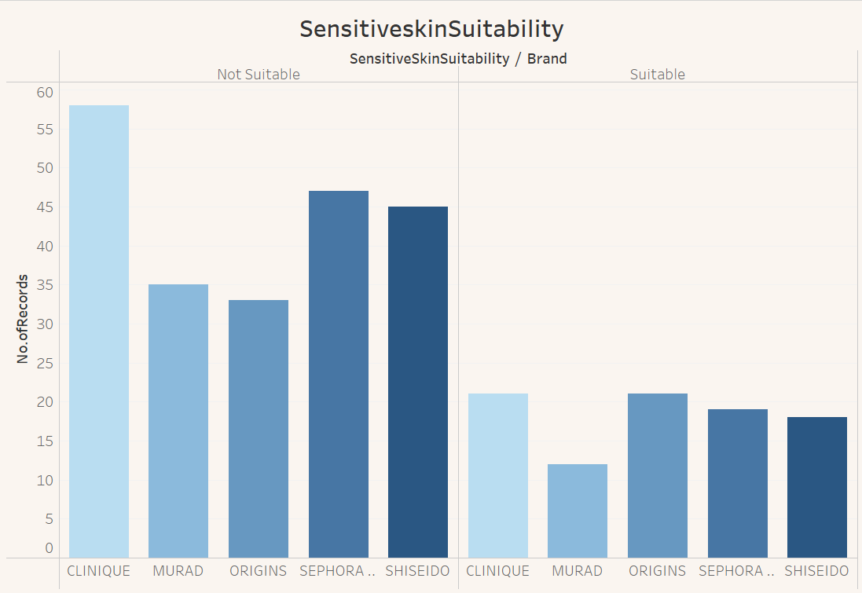

Activity 1.5 : Dry Skin Suitability
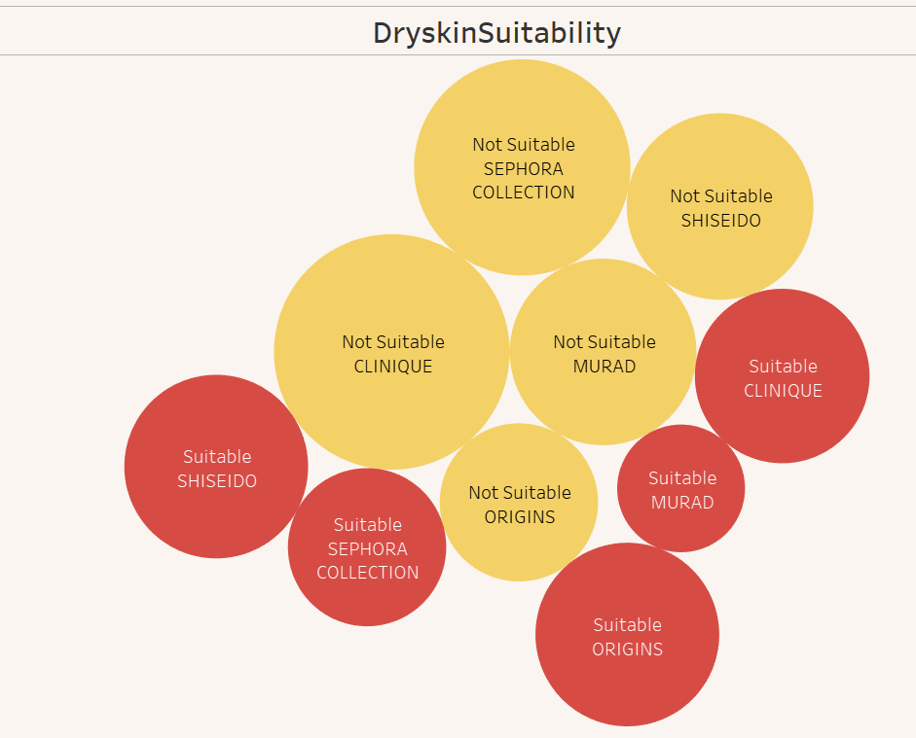
Activity 1.6 : Normal Skin Suitability
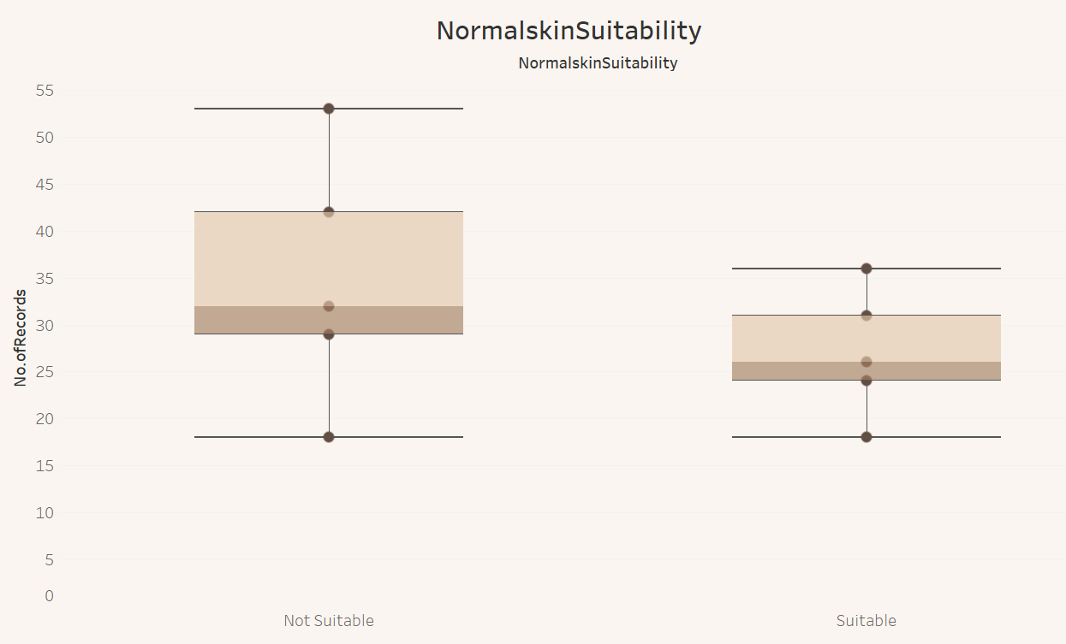
Activity 1.7 : Oily skin suitability
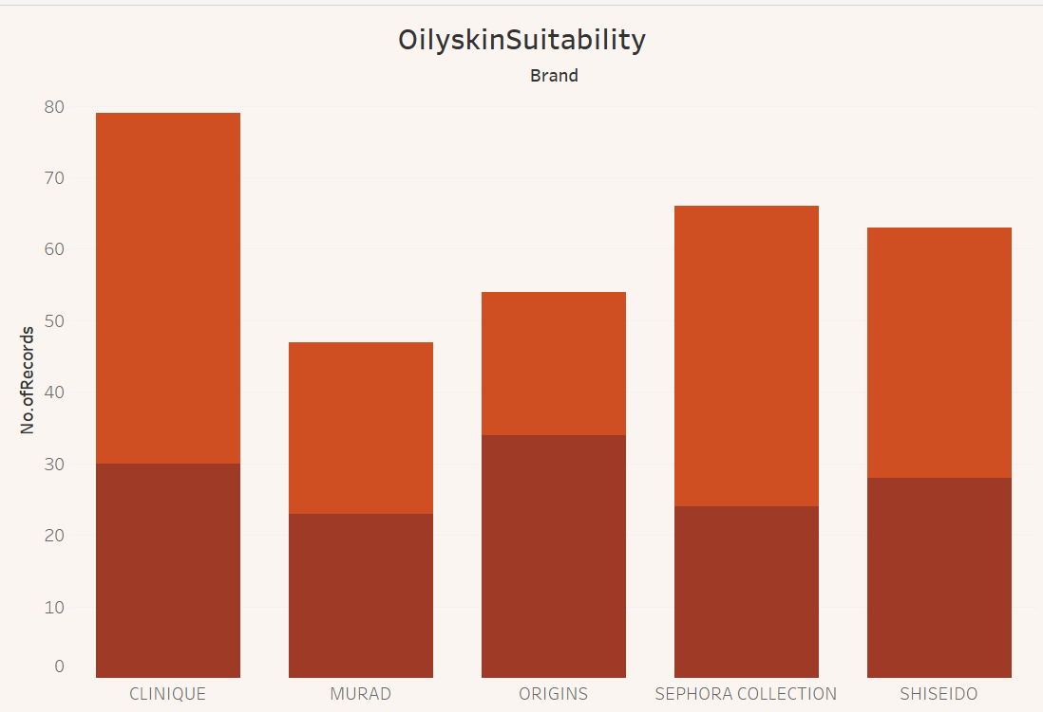

Activity 1.8 : Brand vs Ranking
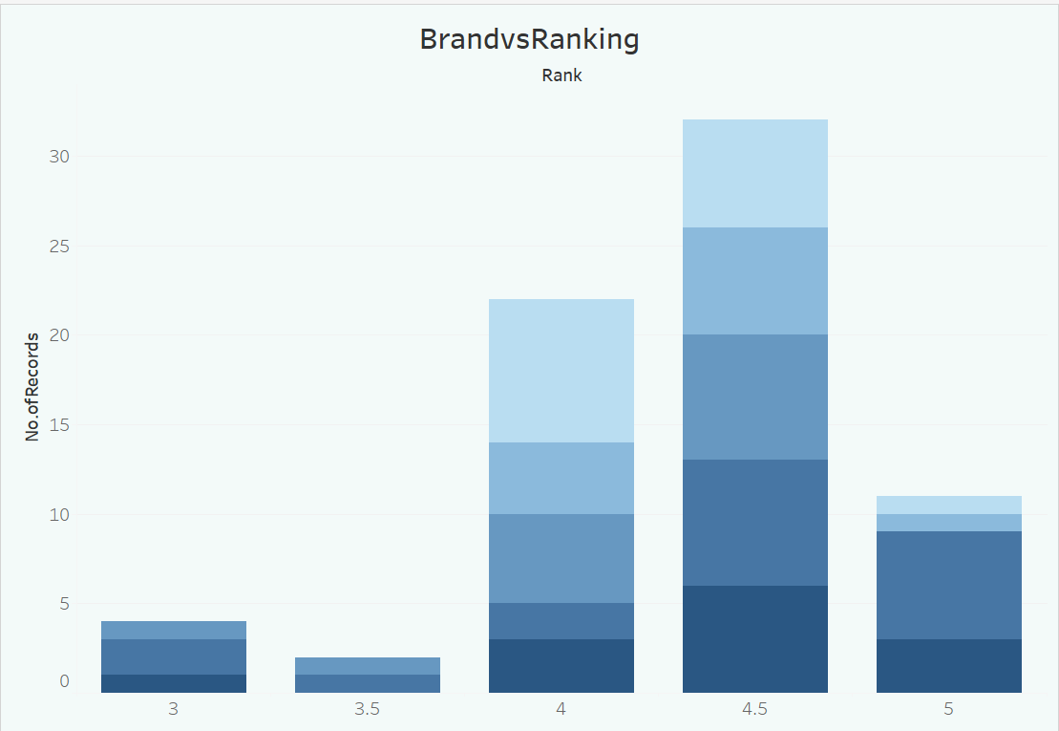
Activity 1.9 : Label vs Ranking
